GRENADA – The Spice Island
March 3-10, 2018
True Blue Bay Resort
Tired of the same old dive resorts and vacation spots? We have picked somewhere new to most of us, but comes highly recommended by those few people that have been there.
Grenada is the south end of the Caribbean. The island isn’t big, just 30 miles long but with more small mountains than most of the Caribbean with cocoa, cloves and many other spices growing wild and on farms. You will see the typical Caribbean critters in the water and more with the influence of South American rivers; macro photography is great here.
Of interest to some is the Bianca C; a 600’ Italian cruise liner that burned and sank upright in 1961. The top is accessible at 90’ for recreational diving and my agent says they can split the dive by dropping divers both on the shallow and deep side of this reef/wreck combo.
Many water activities, live music some nights, Great food, shuttles to town & Grand Anse beach, and that laid back Calypso beat; what more could you possibly want?
The resort is set for Tec divers with several sets of doubles and Side mount systems and they have offered a Tec charter to the Bianca C if there are enough divers interested.

INCLUDED:
- 7 nights std room at True Blue Resort
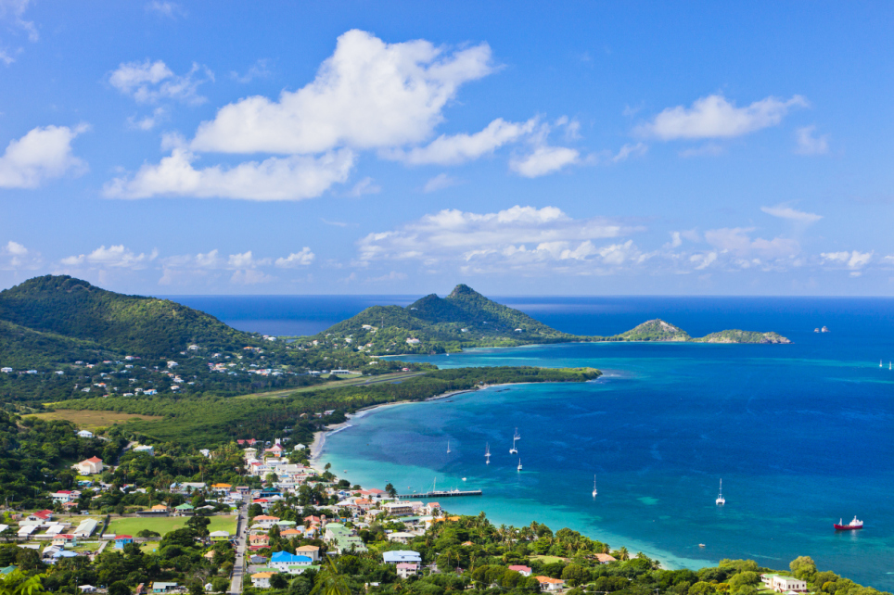
- 5 days of 2-tank diving
- Free 30% Nitrox
- 3 meals a Day
- Drinks including sodas, smoothies & alcohol
- Airport Transfers
- Marine Park Fees
- Water Sports in the Bay
- Free WiFi
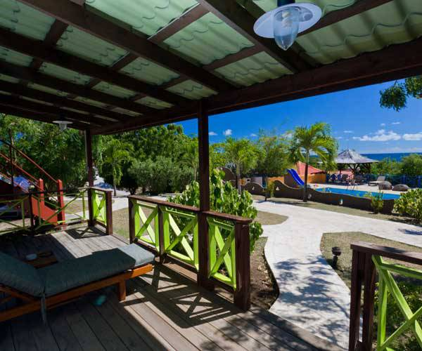
NOT INCLUDED: Airfare
Diver $2149/ dbl occ
Non Diver $1628/ dbl occ
Single Diver $3110

www.truebluebay.com
www.aquanautsgrenada.com

