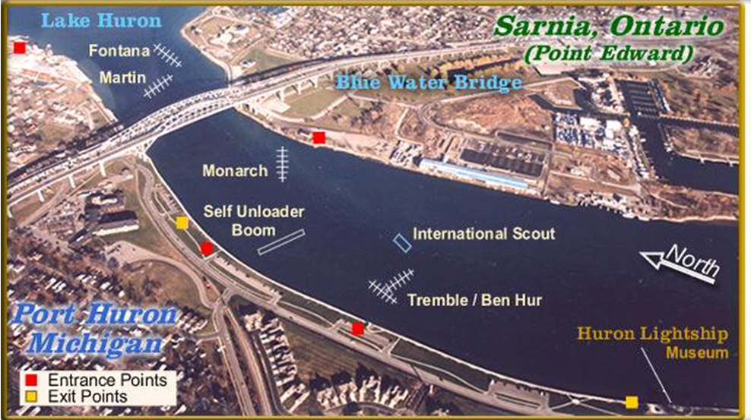
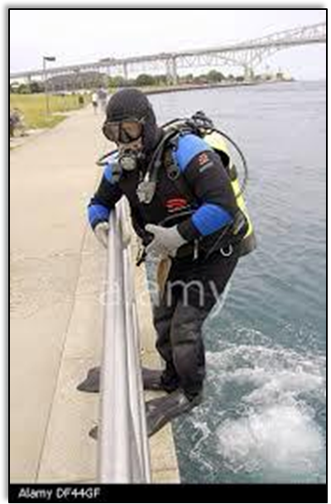
Drift Dive the St. Claire River
September 26 & 27, 2015
Make September memorable with a Drift Dive of the St. Clair River in Port Huron!
Work on PADI Drift Diving or just have a blast experiencing this unique dive.
We will be dive twice on Saturday starting about 11am and at least once on Sunday with our guide, Dave Chidester, who grew up diving this river since he was a teen.
Anyone with moderate dive skills should have no problem with these dives. Entry is a Giant Stride from the sea wall and the exit is climbing up the ladders after removing some gear in a spot out of the current. We will provide help with gear at the exits in the form of baskets for fins, weights, etc. and tag lines to help you to the ladder. We will have a picnic lunch after the first dive.
There will be a meeting at the shop Tuesday, Sept. 22, from 6:30-8pm where Dave and I will lay out the details of diving there and what is needed for PADI DRIFT DIVER.

Follow the link for a video from last year.
https://www.youtube.com/watch?v=9jX_c3G1lvg

616-949-9577 M-F 11-8pm www.americandivezone.com
PADI DRIFT DIVER
Specialty $69.00

- 3 Air Fills Included
………………………………………

Meeting and Guide Fees
w/o Specialty $25.00

