616-949-9577 www.americandivezone.com
CURACAO Nov 2-9, 2019
Oasis Coral Estate Beach, Dive & Wellness Resort
We are going back to Curacao after many years. This is the old Habitat property we stayed at before and we Loved the diving!! Now after extensive renovations along with a new focus and energy it is better than ever and yet has not grown too large.
I remember diving spots like the Mushroom Forest which just mesmerized me and how close that awesome wall is in front of the resort. The new dive shop and lockers are just feet from the boat dock and the new shore entry point. Tanks will be available 24 hours a day.
They have created Two new restaurants with the same great view over the water and took the old restaurant and created a Wellness Spa that has more amenities than I can list, please check the link and plan on relaxing. They even doubled the size of the Endless Pool.
Check the photos for the rooms, they look modern and classy. They still have a covered outside area for each room with chairs which was great last time. The resort has cars available for rent and Willemstad to the east is only 8-9 miles away and West point is only about 12 miles, making it a compact island.
Included: 7 Nights Deluxe room, breakfast, 6 Days 2 tank boat dives, Unlimited shore diving, Nitrox Upgrade, High speed WiFi in Room, In-room safe, Transfers to/from Airport
Not Included: Airfare, Lunch or Dinner, Drinks, Spa ‘package’, hotel or dive Tips
Diver $1425/dbl occ Non Diver $849/dbl occ
Deposit $250
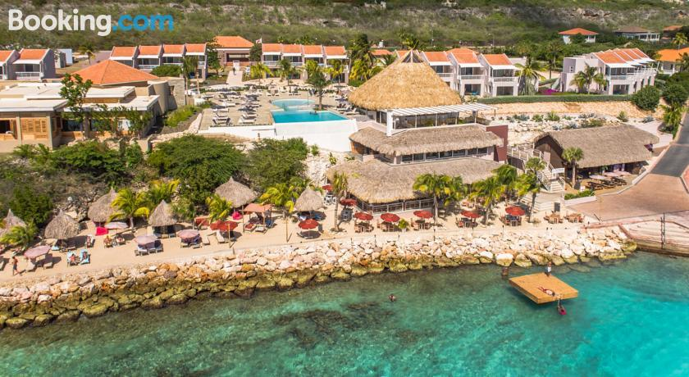
$100 is Non-Refundable/Non-Transferable

coralestate@oasisparcs.com
www.vimeo.com/208483688
www.divecentercuracao.com/en
www.8curacao.com

