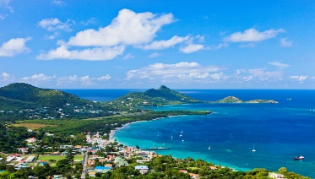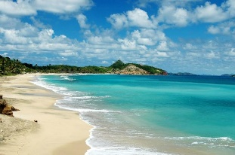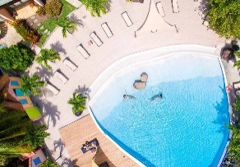
GRENADA – The Spice Island
March 11-18, 2023 True Blue Bay Resort

Tired of the same old dive resorts and vacation spots? We have picked somewhere new to most of us, but comes highly recommended by those few people that have been there.
Grenada is the south end of the Caribbean. The island isn’t big, just 30 miles long but with more small mountains than most of the Caribbean with cocoa, cloves and many other spices growing wild and on farms. You will see the typical Caribbean critters in the water and more with the influence of South American rivers; macro photography is great here.
Of interest to some is the Bianca C; a 600’ Italian cruise liner that burned and sank upright in 1961. The top is accessible at 90’ for recreational diving and last time we were there those who were certified for the depth were able to dive the full boat.
There are many water activities, live music some nights, Great food, shuttles to town & Grand Anse beach, or tours of the island. Along with that laid back Calypso beat, what more could you possibly want?

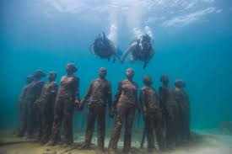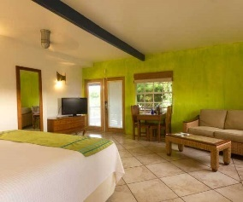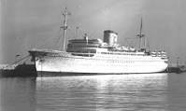

Includes…
-7 Nights at Blue Bay
-Meal Plan
-5 days two tank boat dives/ 10 boat dives
-Transport from/to the Airport
-Free Nitrox

Diver/Dbl Occ. $2275 Non-Diver/dbl Occ $1650 Single Diver $2600
$200 Deposit - $100 is Non-Refundable/ Non-Transferable

